Week-1-01-overview of C,Constants,Variable and data

We're starting out by printing the most famous computing phrase of all time' in the editor below, use either printt oc cout.to print

String Hello, World! to stdout

Input Format

You do not need to read any input in this challenge

Output Format

Print Hello, World! to stdout

Sample Output

Hello World!

**Answers:**

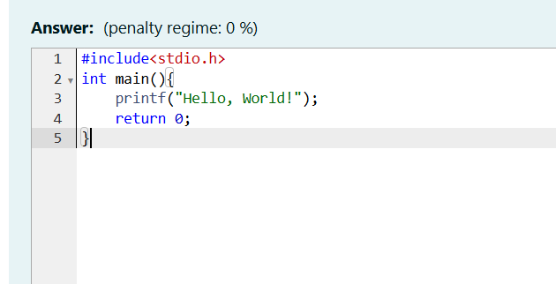

**Output:**

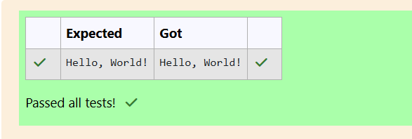

**2.objective:**

This challenge will help you to learn how to take a character, a string and a sentence as input in C

To take a single character ch as input, you can use scanf("%c", &chi; and printf("%c", cho writes a character specified by the argument cher to stdout

char che

scanf("%c", Bech

printf("%c", ch),

This piece of code prints the character ch.

Task

You have to print the character, ch

Input Format

Take a character, ch as input.

Output Format

Print the character, ch

**Answer:**

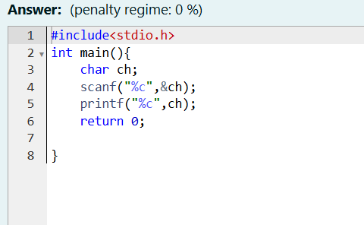

**Output:**

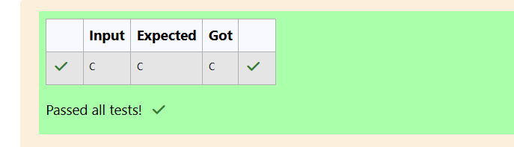

1. **objective:**

The fundamental data types in c are int, float and char. Today, we're discussing int and float data types.

The printf() function prints the given statement to the console. The syntax is printf("format string",argument list); In the function, if we are using an integer, character, string or float as argument, then in the format string we have to write %d (integer), %c (character), %s (string), %f (float) respectively.

The scanf() function reads the input data from the console. The syntax is scanf("format string", argument_list); For ex The scanf("%d",&number) statement reads integer number from the console and stores the given value in variable number

To input two integers separated by a space on a single line, the command is scanf("%d %d", &n, &m), where n and m are the two integers

Task

Your task is to take two numbers of int data type, two numbers of float data type as input and output their sum

1. Declare 4 variables: two of type int and two of type float.

2 Read 2 lines of input from stdin (according to the sequence given in the 'Input Format' section below) and initialize your 4 variables

3, Use the + and operator to perform the following operations:

o Print the sum and difference of two int variable on a new line.

o Print the sum and difference of two float variable rounded to one decimal place on a new line

Input Format

The first line contains two integers.

The second line contains two floating point numbers.

Constraints

1 s integer variables ≤ 104

1≤ float variables ≤ 104

Output Format

D

Print the sum and difference of both integers separated by a space on the first line, and the sum and difference of both float (scaled to 1 decimal place) separated by a space on the second line.

Sample Input

10 4

4.0 2.0

Sample Output

14 6

6.02.0

Explanation

When we sum the integers 10 and 4, we get the integer 14. When we subtract the second number 4 from the first number 10, we get 6 as their difference.

When we sum the floating-point numbers 4.0 and 2.0, we get 6.0. When we subtract the second number 2.0 from the first number 4.0. we get 2.0 as their difference.

Answer: (penalty regime: 0%)

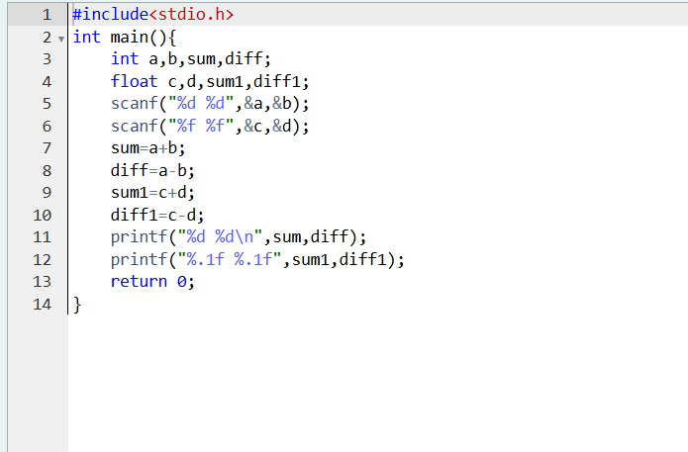

**Output:**

